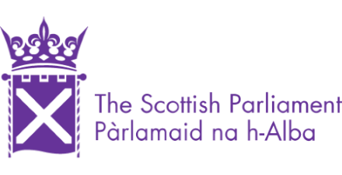

The Festival of Politics 2023
Application Form

Please complete the following:

Name
Date of Birth | dd/mm/yyyy
Email
Phone
Employment Status (Please tick) | In secondary education  In higher education (e.g., College, university)  Employed  Self-Employed  Unemployed  Other (please specify):
(Optional)  SYFF is an organisation that exists to break down barriers, feel free to select any and all barriers that you feel apply to you. | BAME  LGBTQI+  Low income  Disabled  Young Carer  Care Experienced  Geographically Isolated  Female-Identifying  Other:
Please indicate your interest in politics, media, or both | Politics  Media  Both
What do you hope to gain from this opportunity? (max 300 words)
Under the General Data Protection Regulation (GDPR) (EU) 2016/679, we have a legal duty to protect any information we collect from you. Information contained in this form will be treated as strictly private and confidential. In line with the SYFF GDPR Policy, any personal information collected as part of programme recruitment will be securely stored and subsequently destroyed 1 year after project completion.

If you are happy for us to retain your information for potential future opportunities, please tick this box

