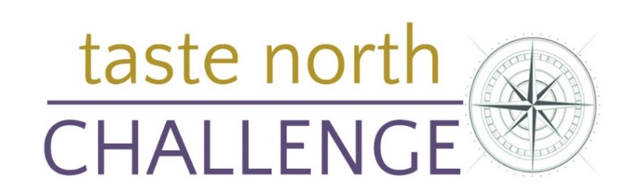
APPLICATION FORM
Taste North Challenge: To create an innovative new baking product which could be enjoyed by visitors attending Taste North 2023. The recipe MUST contain at least one “hero” Caithness & Sutherland ingredient.
All entrants must submit an entry form by Friday 27th October 2023, and deliver their entries to Taste North 2023 on Sunday November 5th at Wick High School by 12:00 noon.
Three category winners will be chosen by our Judging Panel. The first prize per category is a £50 voucher to be spent at Taste North on 5th November 2023. Entrants may apply individually or as part of a group.
NAME/S:
SCHOOL/COLLEGE (if applicable):
CATEGORY: (Up to age 15, 16 - 24 or Open):
EMAIL ADDRESS:
CONTACT NUMBER:
NAME OF DISH:
HERO INGREDIENT:
FULL INGREDIENT LIST:
Please note:
Entries must be delivered to Taste North by 12:00 on Sunday 5th November to be included in the judging process.
A portion of the baking product must be left available for public tasting at Taste North.
Please return your form to: tastenorth@btinternet.com by Friday 27th October 2023.
Category information:
- Up to age 15 Category - open to those up to and including the age of 15.
- 16 - 24 Category open to all applicants between 16 and 24 years old.
- Open Category open to all ages.

